Name: Varia Neel Jitesh
Enrollment No: 250447003019

Network Security And Forensics
Lab Session – 10
Requirement (an open-source rainbow table-based password cracking tool)Hash values of passwords to crackOptional: Any additional rainbow tables or wordlists
Task:
- Compare the cracked passwords with the original list.
- Note how many passwords were successfully cracked.

Rainbow Table-Based Password Cracking (with Ophcrack)
Password cracking involves recovering plaintext passwords from hashed values. Systems store passwords using hashing algorithms such as MD5, SHA-1, and NTLM to prevent direct exposure.

A rainbow table attack is an optimized cryptographic attack that uses precomputed tables to reverse hash values efficiently without performing brute-force operations each time.

What are Rainbow Tables?
A rainbow table is a precomputed dataset containing chains of:
- Plaintext passwords
- Corresponding hash values

Instead of computing hashes repeatedly, attackers search these tables to find matches, significantly reducing cracking time.

Rainbow tables rely on two key functions:
- Hash Function (H): Converts plaintext → hash
- Reduction Function (R): Converts hash → candidate plaintext
Chain Formation:
Password → Hash → Reduce → Hash → Reduce → ...
Only the start and end values of each chain are stored, making the process memory-efficient.

Tools Used
- RainbowCrack
- Ophcrack
What is Ophcrack?
Ophcrack is an open-source password cracking tool that uses rainbow tables to recover passwords, primarily targeting Windows LM and NTLM hashes.

Ophcrack
Loading Hash
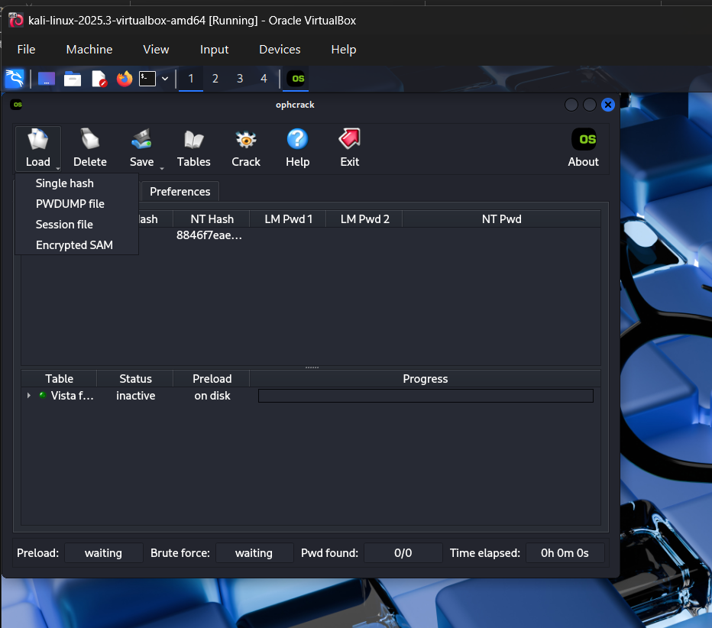

Hash 1: user:1000:aad3b435b51404eeaad3b435b51404ee:8846f7eaee8fb117ad06bdd830b7586c:::
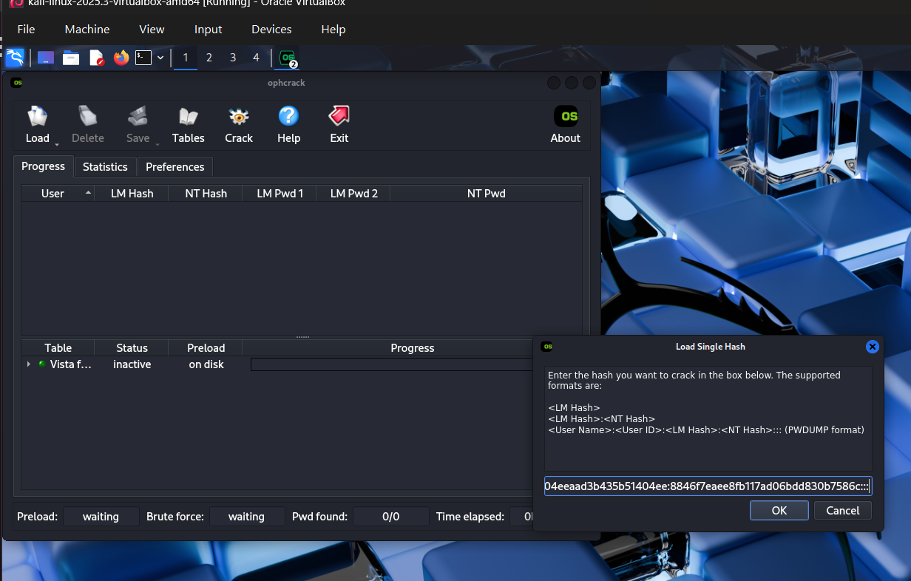

Hash 2:
user:1000:aad3b435b51404eeaad3b435b51404ee:a7a848d921a3c576d780d567182a7431:::
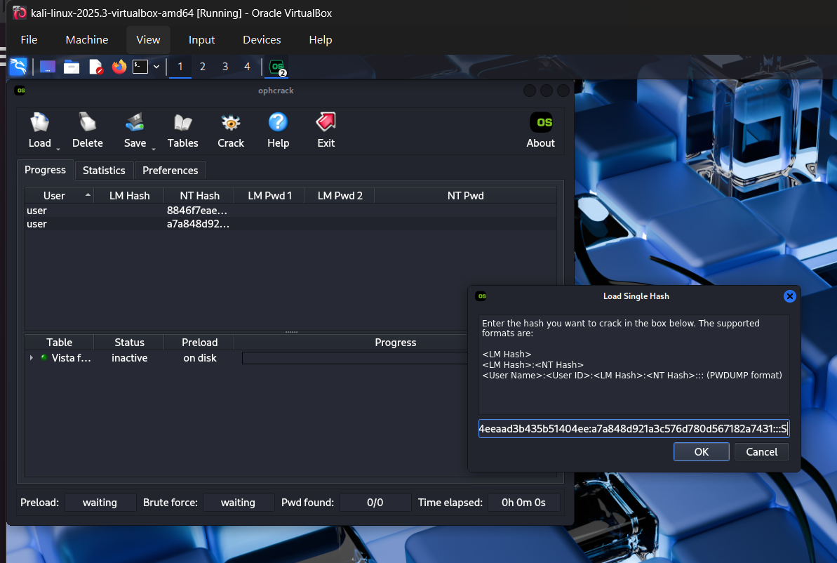

Loading Table in OphCrack
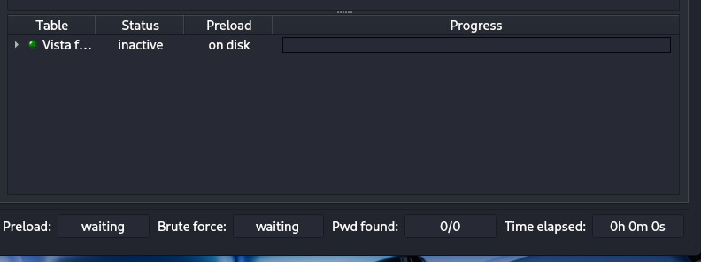

Now we will crack it
